**STRING MANIPULATION OPERATIONS**

**LIKE ‘C%’:**

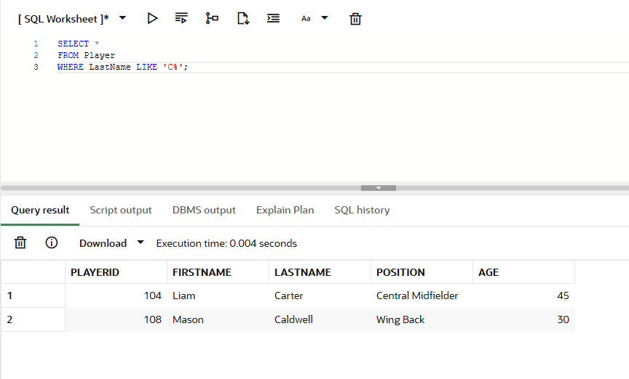

**LIKE ‘%o’:**

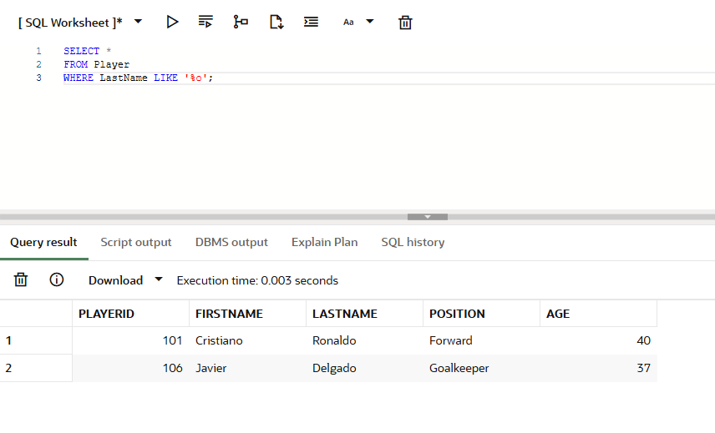

**LIKE ‘%ia%’:**

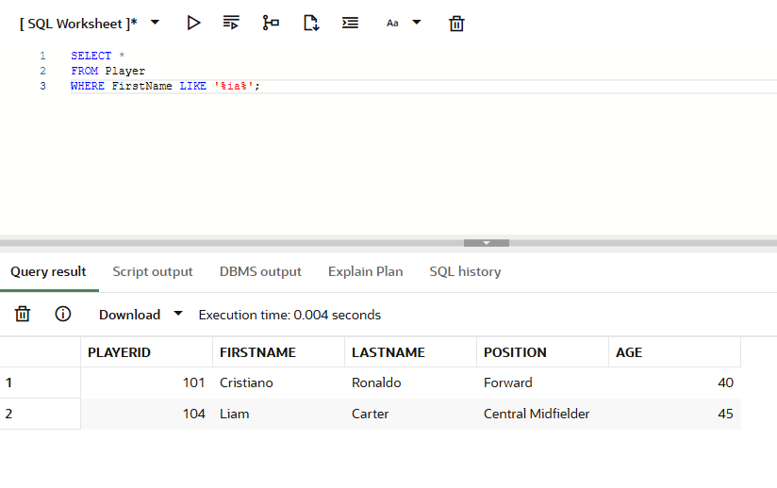

**LIKE ‘ a%’:**

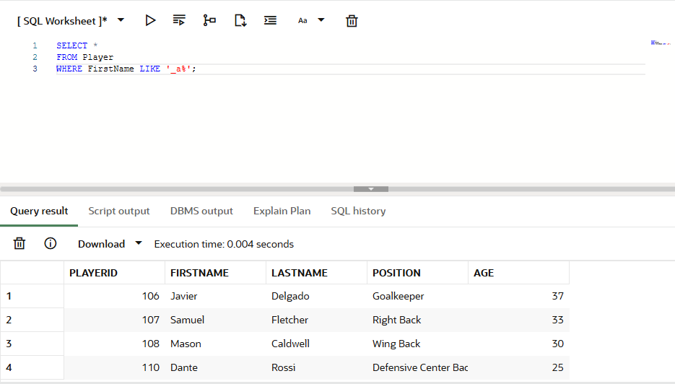

**LIKE ‘L % %’:**

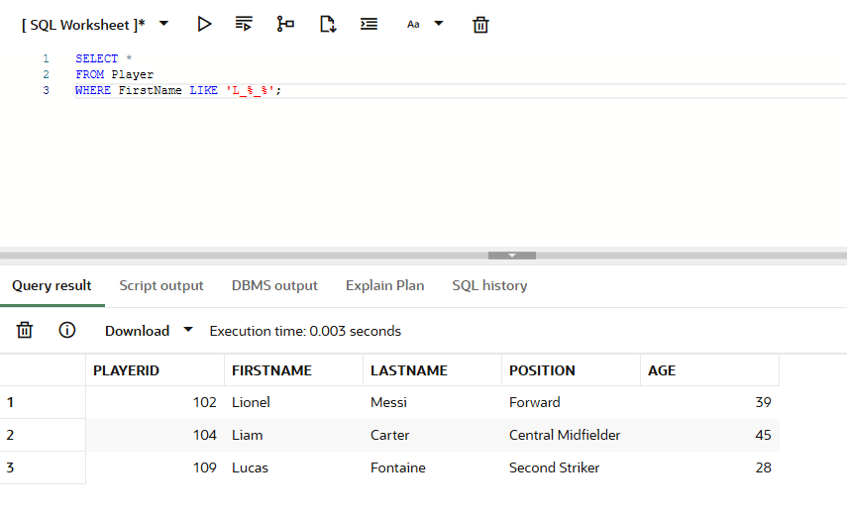

**LIKE ‘F%d’:**

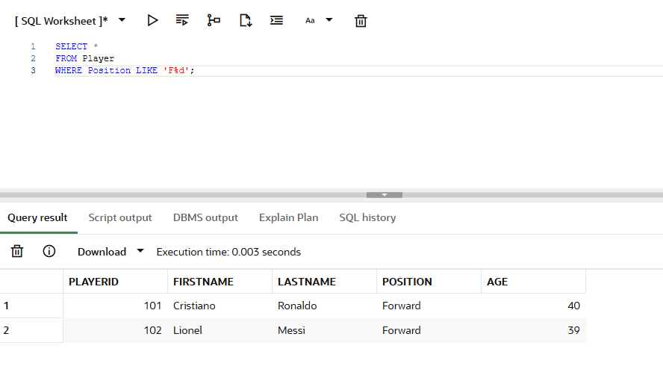

**NOT LIKE ‘L%’:**

